West Yorkshire Fire & Rescue Service

Job Description.

**Post Title: PAIT Engagement Coordinator.**

**Grade: 5**

**Responsible To: Training and Partnerships Manager.**

**Purpose Of Post:** To assist the Fire and Rescue Authority in delivering the Prevention Strategy by developing and managing risk reduction projects for WYFRS. Providing support and guidance to internal colleagues in relation to developing and managing community-based risk reduction activities. Working with district managers to identify and develop local partnership opportunities, managing effective working relationships partner organisations, 3rd sector and community groups to reduce risk.

# Organisational chart.

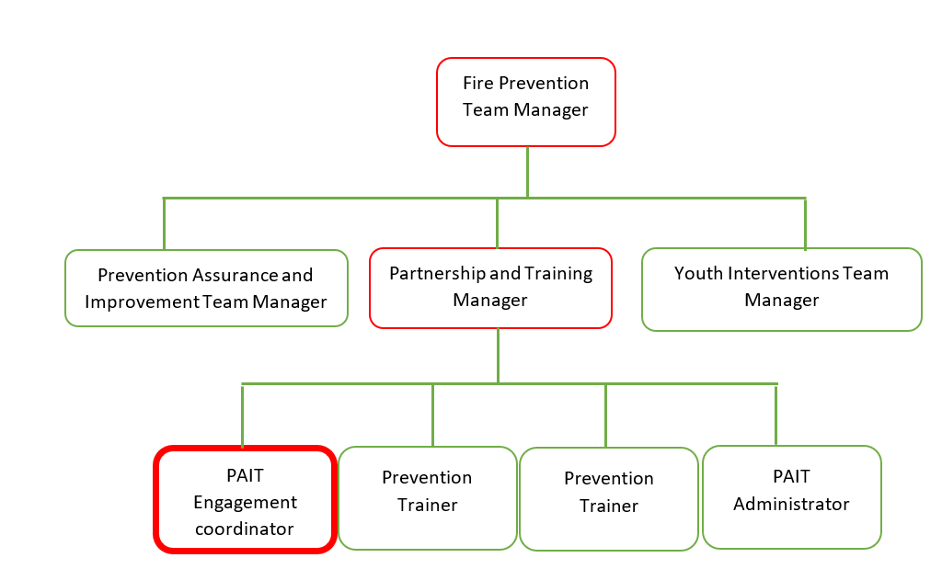

# Main duties and responsibilities of the role.

1. Manage internal and external consultation aimed at reducing risk to develop communication strategies, undertake project management and evaluation, identify funding opportunities and implement best practice across the service.
2. Use analytical skills to interpret data, conduct research and regular horizon scanning to identify emerging risk and issues within the community, working with District Managers to identify and develop partnership opportunities.
3. To act as a subject matter expert representing WYFRS at NFCC national forums and regional meetings and other inter-agency meetings on risk reduction, leading meetings where required. Providing support and guidance to internal colleagues on community-based risk reduction projects.
4. To coordinate Customer Satisfaction Survey, analyse learning to identify gaps and learning across the organisation to improve service delivery.
5. To work with Policy and Training team to develop and implement appropriate guidance, procedures, policies and training as a result of identified learning.
6. Responsible for day-to-day tasking of PAIT Administrator and oversee the Prevention risk-based consultation budget.

# Organisational wide responsibilities.

1. Adherence to the[**NFCC Core Code of Ethics**](https://nfcc.org.uk/our-services/people-programme/core-code-of-ethics/%20Services%20England.pdf)and[**West Yorkshire Fire Service Values**](https://www.westyorksfire.gov.uk/sites/default/files/2023-03/WYFRS%20Core%20Values%20June22.pdf).

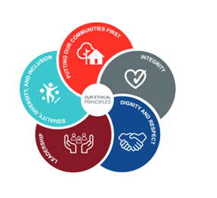

1. To implement and promote the Authority’s:

* Health and Safety policies.
* Equality and Diversity policies.
* Information Security Management System policies.
* Safeguarding policies.
* Business continuity policy and contingency arrangements.
* Policies related to General Data Protection Regulation and Data Protection Act 2018.
* Commitment to maintaining our Customer Service expectations.

1. A satisfactory Enhanced Disclosure and Barring check is required for the role.
2. This post has been designated a hybrid working post which means the postholder’s working time will be split between the workplace and home. The actual pattern and number of days at each will be agreed locally with the line manager and will be determined based on the service needs.

# Skills and experience requirements for this role.

In the supporting statement section of the application form give clear, concise examples of how **you meet all of the Essential person specification criteria** (i.e. items you must be able to do from day one to be able to do the job), **identified as ‘Application’ in order to be shortlisted for this vacancy**. If a large number of applications are received, only those who also meet the Desirable criteria, identified as ‘Application’, will be shortlisted, i.e. criteria you need to do the job, but which could be learnt during training.

**Please list or number the** competency criteria below against which you are providing evidence/examples in order to structure your supporting statement in a well organised way.

There may be some criteria that are identified through ‘Selection Process’ only. **You will only be assessed on these criteria during the selection process and not from your application form**, this may involve tests, presentations, interview etc.

|  | **Experience.** | **Essential/Desirable.** | **Where identified.** |
| --- | --- | --- | --- |
|  | Experience of communicating effectively with individuals of a wide range of ages and backgrounds, hard to reach groups, community groups and agencies to build relationships, present information, deliver relevant and sustainable volunteering opportunities. | Essential. | Application & Selection Process. |
|  | Experience of developing projects and strategies from first concept to finished product. | Essential. | Application & Selection Process. |
|  | Experienced in autonomously coordinating multiple concurrent projects and pieces of work to self-imposed and externally required deadlines with minimal supervision. | Essential. | Application & Selection Process. |
|  | Experience of applying evaluation and monitoring methods to a range of projects and strategies. | Essential. | Application & Selection Process. |
|  | Experienced success in the application of innovative thinking and problem solving to obtain effective outcomes. | Essential. | Application & Selection Process. |

|  | **Education and Training.** | **Essential/Desirable.** | **Where identified.** |
| --- | --- | --- | --- |
|  | Good standard of education to Level 3/A-level standard OR Able to demonstrate an equivalent level of learning gained through life experience with evidence of continuous professional development through formal or informal routes. | Essential. | Application. |
|  | GCSE Grade C or above in English and Maths or equivalent level 2 numeracy and literacy qualification OR able to demonstrate an equivalent level of literacy and numeracy gained through life experience. | Essential. | Application. |
|  | A relevant community development related qualification. | Desirable. | Application. |

|  | **Special knowledge and skills.** | **Essential/Desirable.** | **Where identified.** |
| --- | --- | --- | --- |
|  | Knowledge of national and local agendas for community involvement in delivery of services and community capacity building. | Essential. | Application & Selection Process. |
|  | Develop strategies, policies and protocols as appropriate, including development of multi-agency approaches to delivering community engagement. | Essential. | Application & Selection Process. |
|  | Successfully manage projects to self-imposed and externally required deadlines with minimal supervision. | Essential. | Application & Selection Process. |
|  | Have an understanding of the social and environmental issues affecting community involvement in the promotion of community safety including criminal activity, poverty, mental health issues, homelessness, drug and alcohol related issues. | Essential. | Selection Process only. |
|  | Ability to influence and engage with people from different backgrounds and ethnically diverse groups. | Essential. | Selection Process. |
|  | Use IT (Microsoft Office) effectively in the collation, analysis and presentation of information. | Essential. | Application. |
|  | Demonstrate commitment to good data quality within all areas of work. | Essential. | Selection Process only. |
|  | Demonstrate commitment to and understanding of Equality & Diversity, NFCC Core Code of Ethics and WYFRS values. | Essential. | Selection Process only. |
|  | To hold and maintain a current full UK valid car driving licence. | Essential. | Application & Selection Process. |

Job Description updates: Spring 2022 renamed to: PAIT Engagement Coordinator, [previously titled Projects and Volunteering Co-ordinator, before that Volunteering & Work Skills Coordinator. Reviewed and updated October 2024.